## Agenda for Fifth Meeting

|  |  |  |  |  |
| --- | --- | --- | --- | --- |
|  | | | | |
| **Skyward Federal**  **COPS Platform** | | **2/13/2020**  **1:00 PM to 2:00 PM**  [**https://meet.google.com/ecp-fedi-fbo**](https://meet.google.com/ecp-fedi-fbo)  **NCSU – EB2-2253** | | |
|  | | | | |
|  | | | | |
| Type of meeting: | Project Planning and Implementation | Note Taker:  Facilitator: | Caleb Boswell  Daniel Mills | |
|  | | | | |
|  | | | | |
| Invitees: | Jonathan Balliet, Jeen Shaji, Daniel Mills, Caleb Boswell, Spencer Yoder, Erin Kotlyn, Danny Caudill | | | |
| Please read:  Meeting info: | Questions Below  <https://meet.google.com/ecp-fedi-fbo> | | | |
| **Agenda** | | | | |
|  | | | | |
| Agenda Overview | | All | | 5 min |
| Update | | All | | 5 min |
| Discuss Development Plan | | All | | 10 min |
| Questions | | All | | 20 min |
| Action Items & Next Meeting | | All | | 5 min |
| **Additional Information** | | | | |
|  | | | | |
| Resource persons: | Dr. Jason King, Ms. Margaret Heil, Mr. Richard Kaufman, Erin Kotlyn, Danny Caudill, Ryan Carr | | | |

**Update**

* Interim Project Report has been submitted
* Updated Use cases <https://docs.google.com/document/d/1UN4tFA5segJOnGvCTFvf7au0XM5Ye28QwnPikI6CvVc/edit?usp=sharing>
* Low Level Design

<https://docs.google.com/document/d/1hr9o4MAHRPgG_cD1Is3v2ZbmUpaHB3iM4BCSqccr4-4/edit?usp=sharing>

* Development Plan

<https://docs.google.com/document/d/1qKF64_r_IJin4AKdqhmMuwb-_CjliBTfGNgEwbTK0Nc/edit?usp=sharing>

**COPS Platform Questions**

**Stretch Goals (in order of priority based on relevance and ease of accomplishment)**

1. Encryption: SSL and TLS
2. Automate Admin?
3. Log Aggregator
4. IdAM
5. ~~Platform Controller~~

**Data Storage**

* Sample schema we came up with:

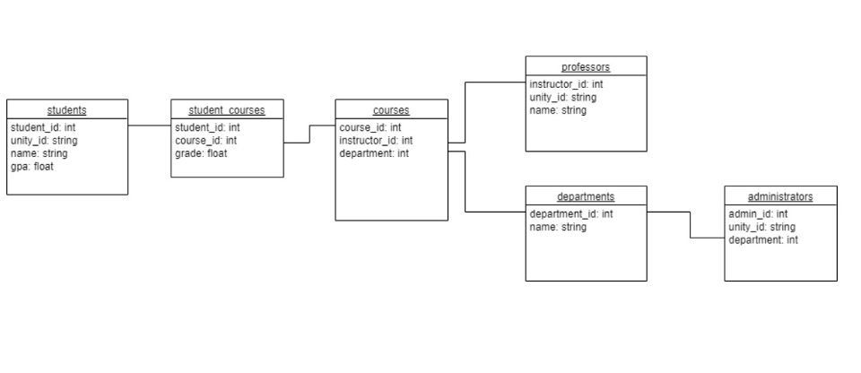

* Administrators have the highest security level, can read/modify everything
* Professors have the next lowest level, can modify course data, enroll students in courses, etc.
* Students cannot see their own grades (this was to have some case for testing column protection), they can see their own information, their courses, and that’s it

**Container Runtime**

* Are we correct that container orchestration is needed for monitoring all of the running container instances? Does it matter whether we use Docker Swarm or Kubernetes for this? - Jonathan
* Should we be monitoring the running state of all containers and attempt to restart if a container transitions to another state unexpectedly (paused, stopped, etc)? - Jonathan

**Software**

* (Asked in Slack as well): The file in our AWS S3 bucket has a .pem extension, but the sample .ssh/config uses a .cer extension. Is there an important difference between these? Is there something I need to do to produce a .cer file? - Daniel

**Front-end**

* We would like to develop a very basic frontend to show off our project (still deciding on CLI or GUI). Is there any front-end functionality we could implement that would be useful for this system? - Jonathan
* Logging, Admin, Green if everything is good - red if something broke: status report
* PG Audit?

**Logging**

* We have two use cases for logging. One to log every action and one for the user to see. The user can see who else is accessing the same information. Is this something beneficial or should we not do it? - Jeen
* It is a security hole. No need for user to see

**Other**

* To run GitLab
  + Bastion, Proxy, and Keycloak need to be running
* How to pass SELinux label in the request
  + Use a POST - label is passed in the body of the request, NOT the URL

**Fifth Sponsor Meeting Minutes**

**Team**: Skyward Federal – MLS API Part 1 **Date**: February 13, 2020

**Facilitator**: Daniel Mills **Recorder**: Caleb Boswell

**Attendance**:

* Spencer Yoder
* Jeen Shaji
* Jonathan Balliet
* Daniel Mills
* Caleb Boswell
* Danny Caudill
* Erin Kotlyn

**Minutes:**

* Updated sponsor on tasks group worked on.(Ex. IPR submission, use case adjustments, etc.)
* Talked about use cases and development plan
* Discussed data schema created by Spencer for populating data for testing and confirmed opinion of sponsor, which was positive. Discussion included clearly defining what parts of schema would be separated by security level.
* Confirmed with sponsor if it was fine to use other container tools depending on which would be most beneficial. Sponsor response was that the use of more practical container software was acceptable, Kubernetes was recommended.
* Discussed monitoring state of containers in case error occurs. Sponsor mentioned that Kubernetes had a method of handling such situations.
* Discussed necessity of developing frontend for project presentation and asked whether we should incorporate functionality that will be useful for general system. Sponsor suggested creating a frontend that can aggregate the different features of the program such as logging.
* Discussed currently described use cases for logging and sponsor’s opinion on them.
* Confirmed if any of the stretch goals were unable to be accomplished by our team or were handled by sponsor instead. Informed platform controller to be to complex for our team and types of encryption that could be used.
* Discussed recommended approaches for development of project.
* Confirmed if the 70% coverage goal was fine with sponsor, they confirmed it was an acceptable goal.

|  |  |  |
| --- | --- | --- |
| **Action Item** | **Person Responsible** | **Due Date** |
|  |  |  |
|  |  |  |
|  |  |  |
|  |  |  |
|  |  |  |
|  |  |  |
|  |  |  |

**Meeting Evaluation:**

* **Positive -**
* **Negative -**

**Next Meeting:**